**DECLARATION**

I hereby declare that the report titled “**Hacking lab using Kasm”** submitted by me to VIT Chennai is a record of bona-fide work undertaken by us under the supervision of **: Prof. Gayathri R**, School of Computer Science and Engineering, Vellore Institute of Technology, Chennai.



Signature of the Candidate

**Sam Methuselah**

**Reg. No. 19BCE1698**



Signature of the Candidate

**Mihir Antwal**

**Reg. No. 19BCE1641**

i

## CERTIFICATE

Certified that this project report entitled “**Hacking lab using Kasm”** is a bonafide work of **Mihir Antwal (19BCE1641) and Sam Methuselah (19BCE1698)** and they carried out the Project work under my supervision and guidance for ECE3502 – IoT Domain Analyst.

**Gayathri R**

SCOPE, VIT Chennai

ii

## ACKNOWLEDGEMENT

We wish to express our sincere thanks and deep sense of gratitude to our project guide, **Prof. Gayathri R** for her consistent encouragement and valuable guidance offered to us in a pleasant manner throughout the course of the project work.

We are extremely grateful to **Dr. Ganesan R.**, Dean of School of Computer Science Engineering, VIT Chennai, for extending the facilities of the School towards our project and for his unstinting support.

We express our thanks to our Head of the Department **D**r. **Nithyanandam P** for his support throughout the course of this project.

We also take this opportunity to thank all the faculty of the School for their support and their wisdom imparted to us throughout the course.

We thank our parents, family, and friends for bearing with us throughout the course of our project and for the opportunity they provided us in undergoing this course in such a prestigious institution.

Signature of the Candidate

**Sam Methuselah**

**Reg. No. 19BCE1698**



Signature of the Candidate

**Mihir Antwal**

**Reg. No. 19BCE1641**

iii

## ABSTRACT

In the dawn of international conflicts, terrorist organizations funding cybercriminals to breach security systems, either to compromise national security features or to extort huge amounts by injecting malware and denying access. Resulting in the steady rise of cybercrime. Organizations face the challenge of updating hack-preventing tactics, installing several technologies to protect the system before falling victim to the hacker.

New worms, malware, viruses, and ransomware are primary benefit are multiplying every day and is creating a need for ethical hacking services to safeguard the networks of businesses, government agencies or defense.

Ethical hackers learn and perform hacking in a professional manner, based on the direction of the client, and later, present a maturity scorecard highlighting their overall risk and vulnerabilities and suggestions to improve. Hacking-Lab is a legal place to do some hands-on exercises in the field of cyber security, including web, penetration testing, reverse engineering, forensics and more.

This project’s motive is to create an ultimate hacking workspace. This can be an everyday useful thing. It can completely change the game for ethical hackers. As ethical hackers research on hacking stuff almost on a daily basis and there are some sketchy links out there, but with one click a new browser opens, which is isolated, secure and it's not even on their machine. With this even if it’s a malicious link, it doesn't matter. And when the work is done, the session can be deleted without any trace, as if it never existed. This doesn't involve some heavy virtual machines or WSL. It’s Docker containers streaming to your browser.

**Keywords:** Kasm; Docker; Ethical Hacking; Linux; Hacker; Isolated Lab; Hacking Workspace

iv

**CONTENTS**

Declaration i

Certificate ii

Acknowledgement iii

Abstract iv

1. Introduction………………………………………………………….1
   1. Objective and goal of the project 1
   2. Technologies Used. 1
2. Literature Survey………………………………………………………... 4
3. Proposed System……….……………………………………………… 5
   1. System Flow 5
4. Requirements Specification……………………………………………. 6
   1. Hardware Requirements 6
   2. Software Requirements 6
5. Implementation...……………………………………………………6
6. Results & Conclusion………………………………........................15
7. References………………………………………………………….15

Appendix <Sample code, snapshot etc.>…………………………..17

# INTRODUCTION

* 1. **OBJECTIVE AND GOAL OF THE PROJECT**

Ethical hacking is used to secure important data from enemies. It works as a safeguard of your computer from blackmail by the people who want to exploit the vulnerability. Using ethical hacking, a company or organization can find out security vulnerability and risks. Governments use State-sponsored hacking to prevent intelligence information about influence politics, an enemy state, etc. Ethical hacking can ensure the safety of the nation by preventing cyber-terrorism and terrorist attacks. Hackers can think from an attacker's perspective and find the potential entry point and fix them before any attacks. Ethical hacking helps us learn new skills used in many roles like software developer, risk management, quality assurance tester, and network defender. In a company, the trained ethical hackers are the main strength. To ensure the functions of software aptly, ethical hackers can apply quick security tests under extreme and standard conditions. Ethical hackers develop many tools and methods and quality assurance tester to eliminate all the system's vulnerabilities.

The objective of this project is to provide these ethical hackers with an ultimate hacking lab/workspace where they can access any link and perform any kind of training and testing with the click of a button. They can open malicious links without a single care as they can destroy the entire session. Also, they can work with Kali Linux inside a browser!. This project will also help normal users as with this they can apply web filter for websites, perform staging, open suspicious links in Kasm and many more.

* 1. **TECHNOLOGIES USED**

**1.2.1 Docker**

Docker is an open-source containerization platform. It enables developers to package applications into containers—standardized executable components combining application source code with the operating system (OS) libraries and dependencies required to run that code in any environment. Containers simplify delivery of distributed applications, and have become increasingly popular as organizations shift to cloud-native development and hybrid multicloud environments. Developers can create containers without Docker, but the platform makes it easier, simpler, and safer to build, deploy and manage containers. Docker is essentially a toolkit that enables developers to build, deploy, run, update, and stop containers using simple commands and work-saving automation through a single API.

Containers are made possible by process isolation and virtualization capabilities built into the Linux kernel. These capabilities - such as control groups (Cgroups) for allocating resources among processes, and namespaces for restricting a processes access or visibility into other resources or areas of the system - enable multiple application components to share the resources of a single instance of the host operating system in much the same way that a hypervisor enables multiple virtual machines (VMs) to share the CPU, memory and other resources of a single hardware server. As a result, container technology offers all the functionality and benefits of VMs - including application isolation, cost-effective scalability, and disposability.

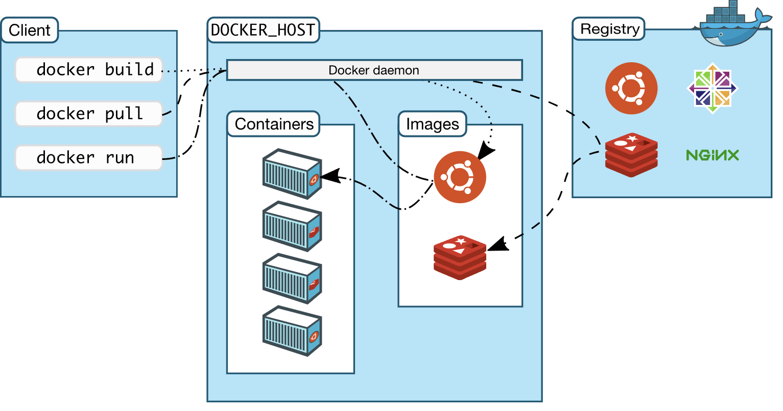

*Figure 1- Docker Overview*

**1.2.2 Kasm**

Kasm Workspaces is changing the way that businesses secure sensitive data using our Containerized Desktop Infrastructure (CDI) and browser-based rendering technology. Developed for secure collaboration on highly sensitive Government/Defense programs, this technology allows users to seamlessly interact with sensitive data through the web browser while also protecting the data from being taken or shared. Kasm is not just a service, but a highly configurable platform, with a robust developer API. It provides a safe, secure and disposable environment. When visiting a website in Kasm, no website code runs on your system, only the cloud browser or desktop, protecting the system from compromised websites and the latest malware. Kasm was developed by a team of cybersecurity experts to meet the secure collaboration and remote workforce requirements of the US Government, but is now available to companies of all sizes/industries

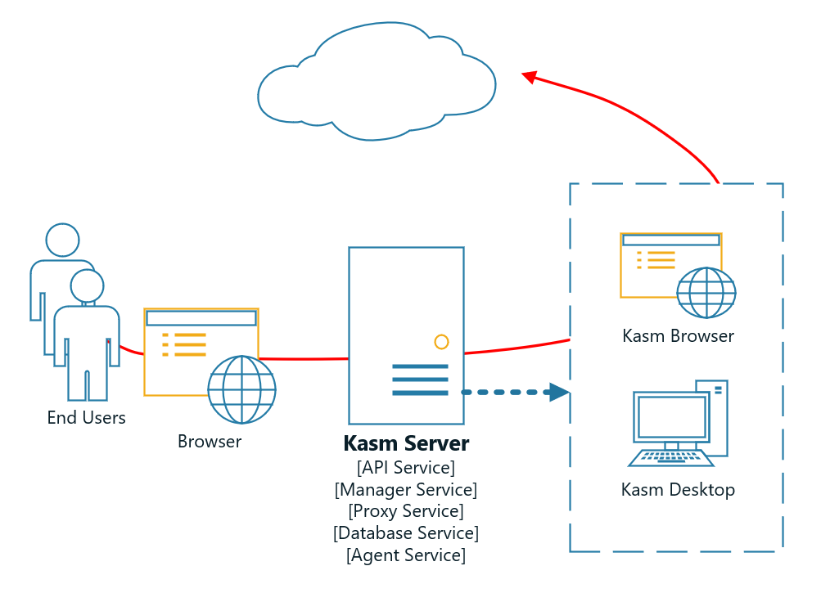

*Figure 2- Kasm Workspace Flow*

# LITERATURE SURVEY

The paper titled “OpenStack and Docker: building a high-performance IaaS platform for interactive social media applications” [1] describes about the Nova-Docker plugin which enables the fast and efficient provisioning of computing resources which can run as a Hypervisor that helps to manage the growth of application users. This is built using an OpenStack IaaS which enables to control

data centres for cloud computing. OpenStack standard architecture contains three important roles: Nova, that manages the computation, storage resources are managed by Cinder. The entire networking resources are managed by Neutron across multiple data centre. NUBOMEDIA is another approach which enables (PaaS) interactive social media through cloud. The major technologies adopted are Kurento Media Server (KMS) which provides interactive communications through WebRTC media server. OpenBaton which manages the lifecycle of media server capabilities using Docker containers. In order to host applications which consumes media server capabilities, OpenShift Origin is enabled. Developers and Administrators are interested more in Docker container than Kernel-based Virtual machine mainly for its Fast Boot time, Direct Access to containers, it can be run on any hardware that supports Linux based OS. Docker containers are lightweight, minimizing the bandwidth needed for deployment using required resources [8].

The paper titled “Evaluation of Docker as Edge Computing Platform” [2] describes about how to overcome problems such as High latency, network bottleneck and network congestion. We can achieve this from moving centralized to decentralized paradigm, Edge computing will be able to reduce application response time for better user experience. Edge computing is enabled with Docker, a platform of container-based technology that has more advantages over VM based Edge computing. This paper mainly evaluates the fundamental requirement for EC that are

1. Deployment and Termination which mainly describes the platform that provides an easy way to manage, install and configure services to deploy the low-end devices.
2. Resource and Service Management that allows users to use the services even when the resources are out of limit.
3. Fault Tolerance which relies on the High availability and reliability to the user.
4. Caching allows the user to experience better performance where Docker images can cache at the Edge.

One such that enables Docker concept which was applied on Hadoop Streaming which reduces the setup time and configuration errors. Overall, there are areas of improvement yet, it provides elasticity and good performance.

# PROPOSED SYSTEM

# 3.1 SYSTEM FLOW

The existing system based on Kasm works as described below. So, you install Kasm on your server. Now, if you want to open up a secure web browser, or even an instance of call Linux, Kasm will automatically open this up in a Docker container and stream it to your browser. And it does this using Kasm proprietary software. So, these Docker containers are just regular containers on Docker hub. We can go look at them and can even create your own custom Docker images. Whenever you're surfing the internet or doing some hacking stuff in Kali, you're using the clouds IP address. So, whereas, normally we would be going directly to the ISP using home internet IP address using Kasm. This will kind of hide the identity of the user especially from the ISP, keeping the user a bit anonymous giving the user the benefit of using this from anywhere.

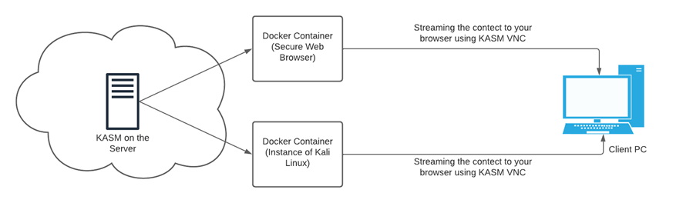

*Figure3- Proposed System*

# REQUIREMENTS SPECIFICATION

* 1. **HARDWARE REQUIREMENTS**

Server-

* vCPUS: 2 and above
* RAM: 4GB and above
* Storage: 50GB and above

Client-

* Memory: 4 GB and above
* Graphics Card: AMD Radeon R5 M230 and above
* CPU: Intel Core i3-2340UE and above
* File Size: 50 GB and above
* OS: Windows 7,8,8.1 and above
  1. **SOFTWARE REQUIREMENTS**
* Browser (Chrome, Brave and Mozilla Firefox)

# IMPLEMENTATION

**Creation of Server in Azure-**

* Type virtual machines in the search.
* Under Services, select Virtual machines.
* In the Virtual machines page, select Create and then Virtual machine. The Create a virtual machine page opens.
* In the Basics tab, under Project details, make sure the correct subscription is selected and then choose to Create new resource group. Type myResourceGroup for the name.
* Under Instance details, type myVM for the Virtual machine name and choose the best suitable server as per the requirements for the Image. Leave the other defaults.
* Under Administrator account, provide a username, such as azureuser and a password. The password must be at least 12 characters long and meet the defined complexity requirements.
* Under Inbound port rules, choose Allow selected ports and then select RDP (3389) and HTTP (80) from the drop-down.
* Leave the remaining defaults and then select the Review + create button at the bottom of the page.
* After validation runs, select the Create button at the bottom of the page.
* After deployment is complete, select Go to resource.

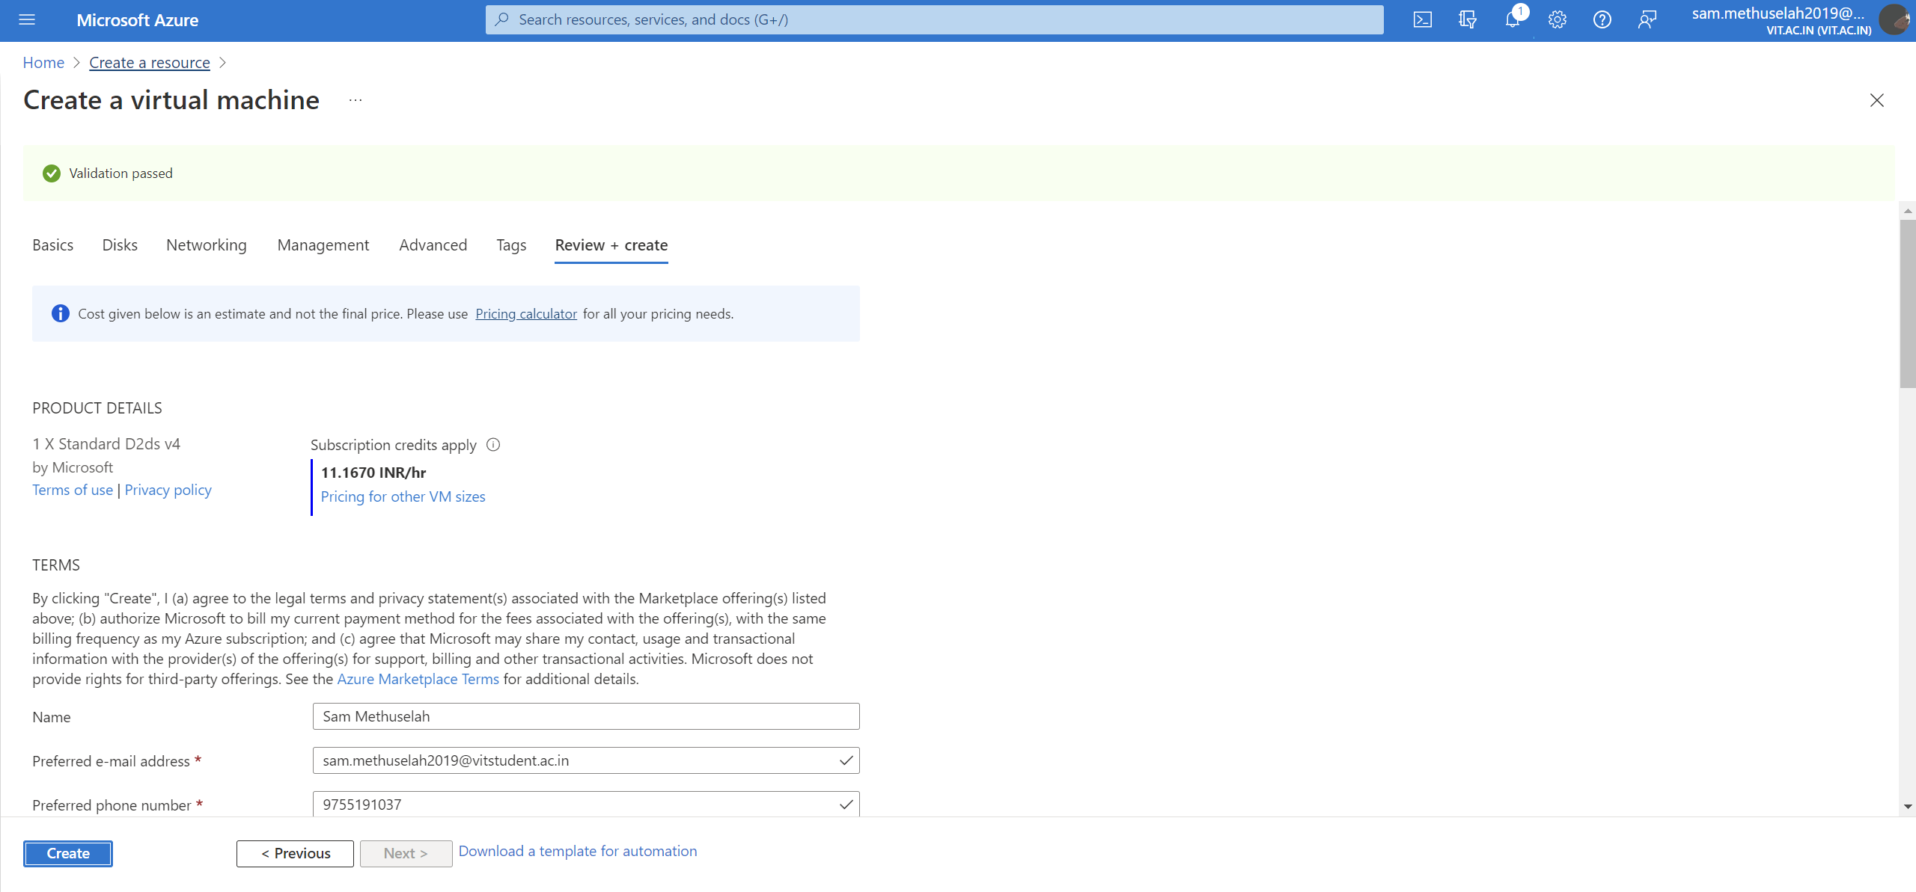

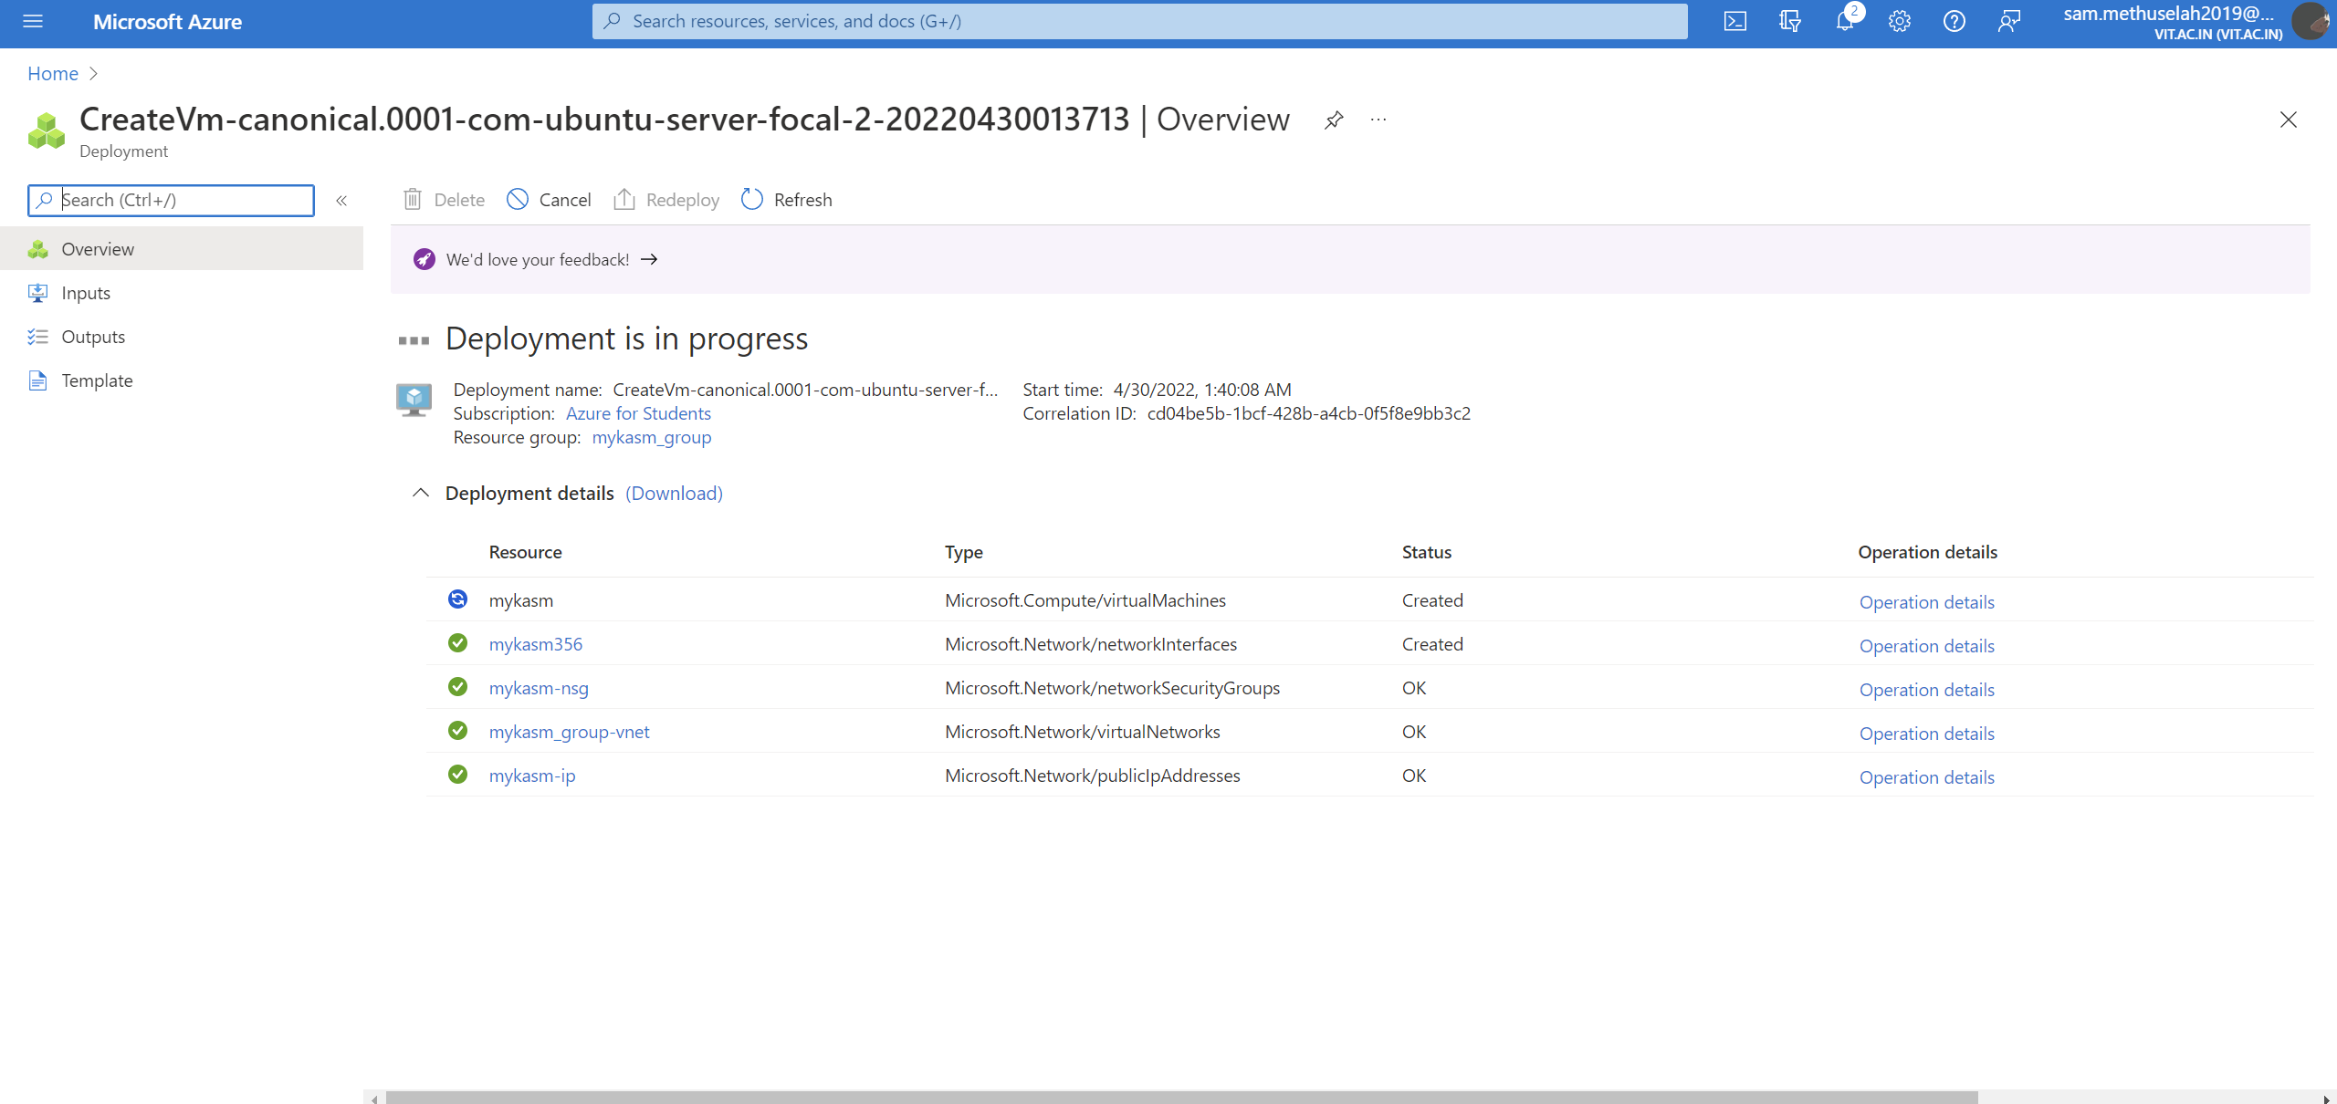

*Figure 4- Server Creation in Azure*

**Connecting to our Server-**

* Go to the Azure portal to connect to a VM. Search for and select Virtual machines.
* Select the virtual machine i.e. server from the list.
* At the beginning of the virtual machine page, select Connect.
* On the Connect to virtual machine page, select SSH, and then enter the private key path as in the keyholder.
* Then copy the command generated below.
* Open command prompt in the native device and paste and run the command.
* Type “yes” for the confirming connection.
* Enter the password of virtual machine set by you and finish logging on.

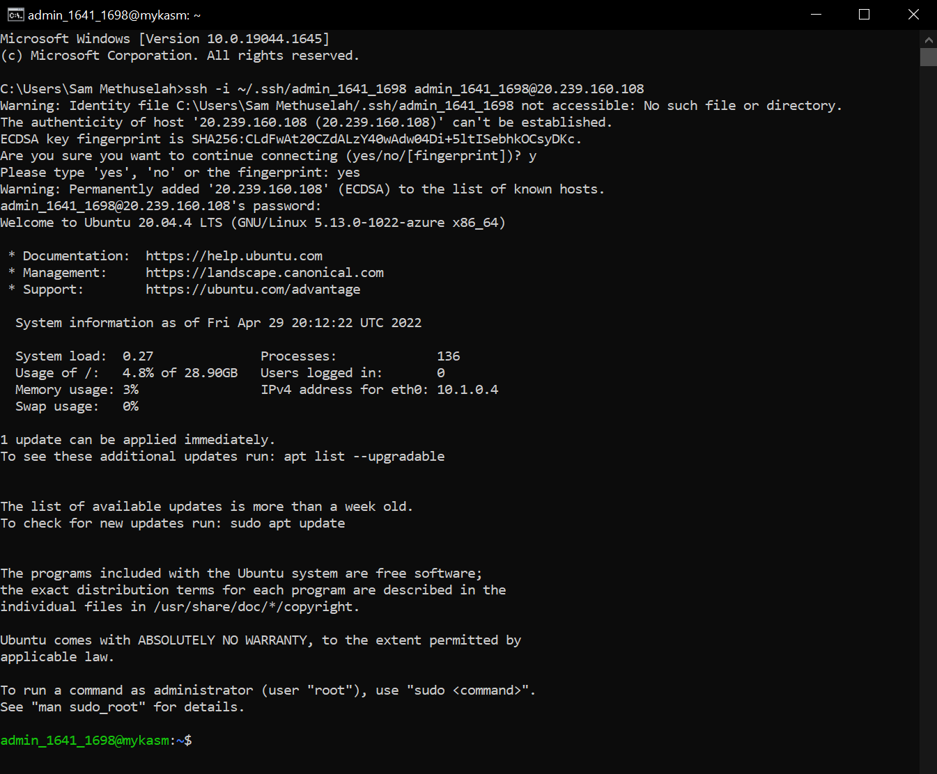

*Figure 5- Connecting to Server (VM)*

**Installing Kasm on the Server-**

First we need to do SWAP partition. The following steps will create a 1 gigabyte (1024MB) Swap partition. It is recommended to allocate 1 gigabyte per concurrent session you expect to run at any given time.

sudo dd if=/dev/zero bs=1M count=1024 of=/mnt/1GiB.swap

sudo chmod 600 /mnt/1GiB.swap

sudo mkswap /mnt/1GiB.swap

sudo swapon /mnt/1GiB.swap

Verify swap file exists

cat /proc/swaps

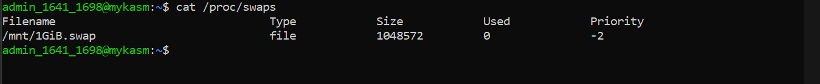

To make the swap file available on boot

echo '/mnt/1GiB.swap swap swap defaults 0 0' | sudo tee -a /etc/fstab

Download the latest version of Kasm Workspaces and extract the package and run the installation script.

wget https://kasm-static-content.s3.amazonaws.com/kasm_release_1.10.0.238225.tar.gz

tar -xf kasm_release*.tar.gz

sudo bash kasm_release/install.sh

After installation we get some credentials, save them.

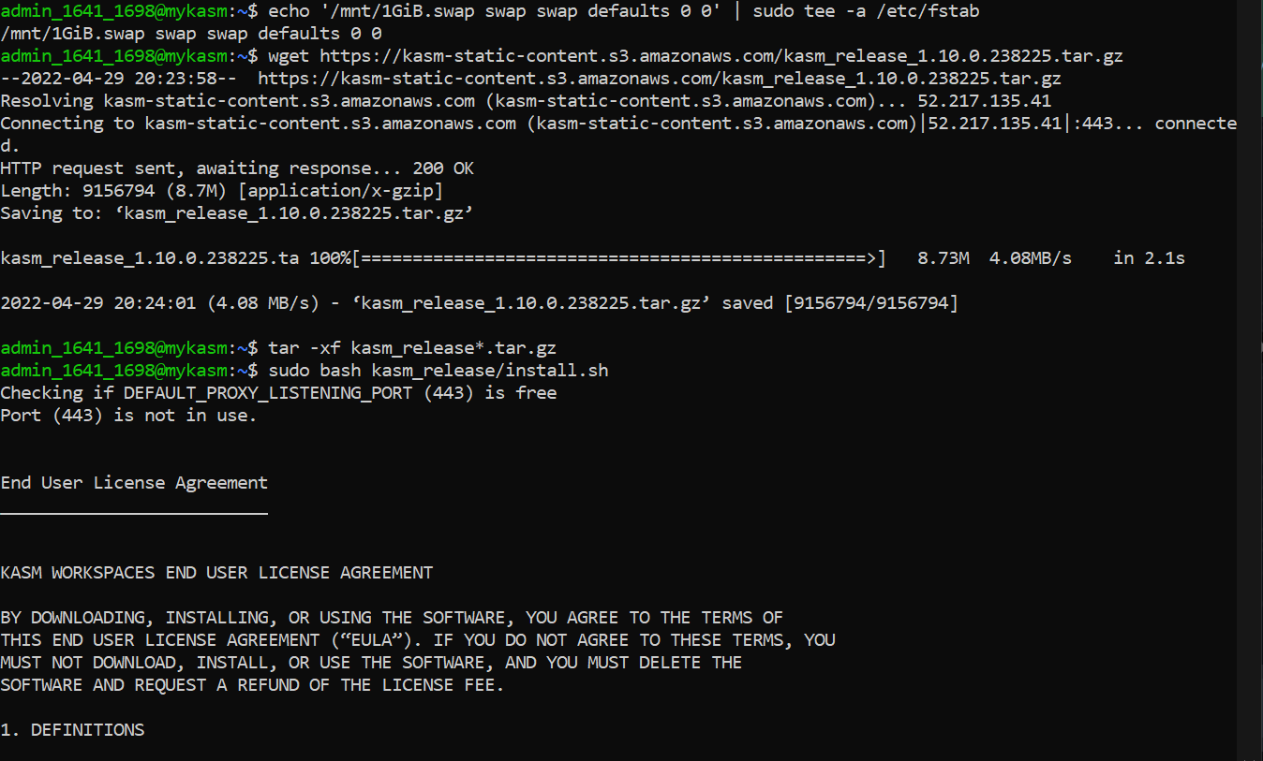

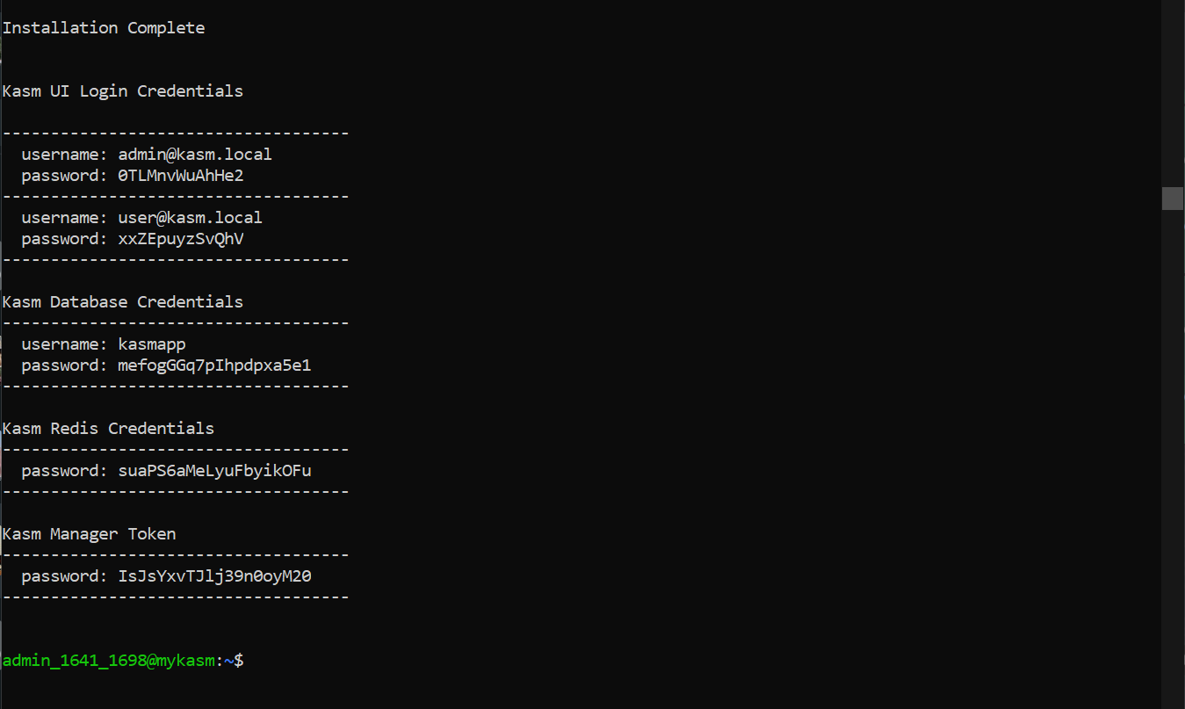

*Figure 6- Installation of Kasm on Server(VM)*

**Opening Kasm Workspace-**

* Copy the IP address of the VM from Azure
* Open up a new tab and type https://” and paste in the IP address
* Login with the admin credentials.

Once logged on we'll be presented with the Kasm console. There are a lot of settings.

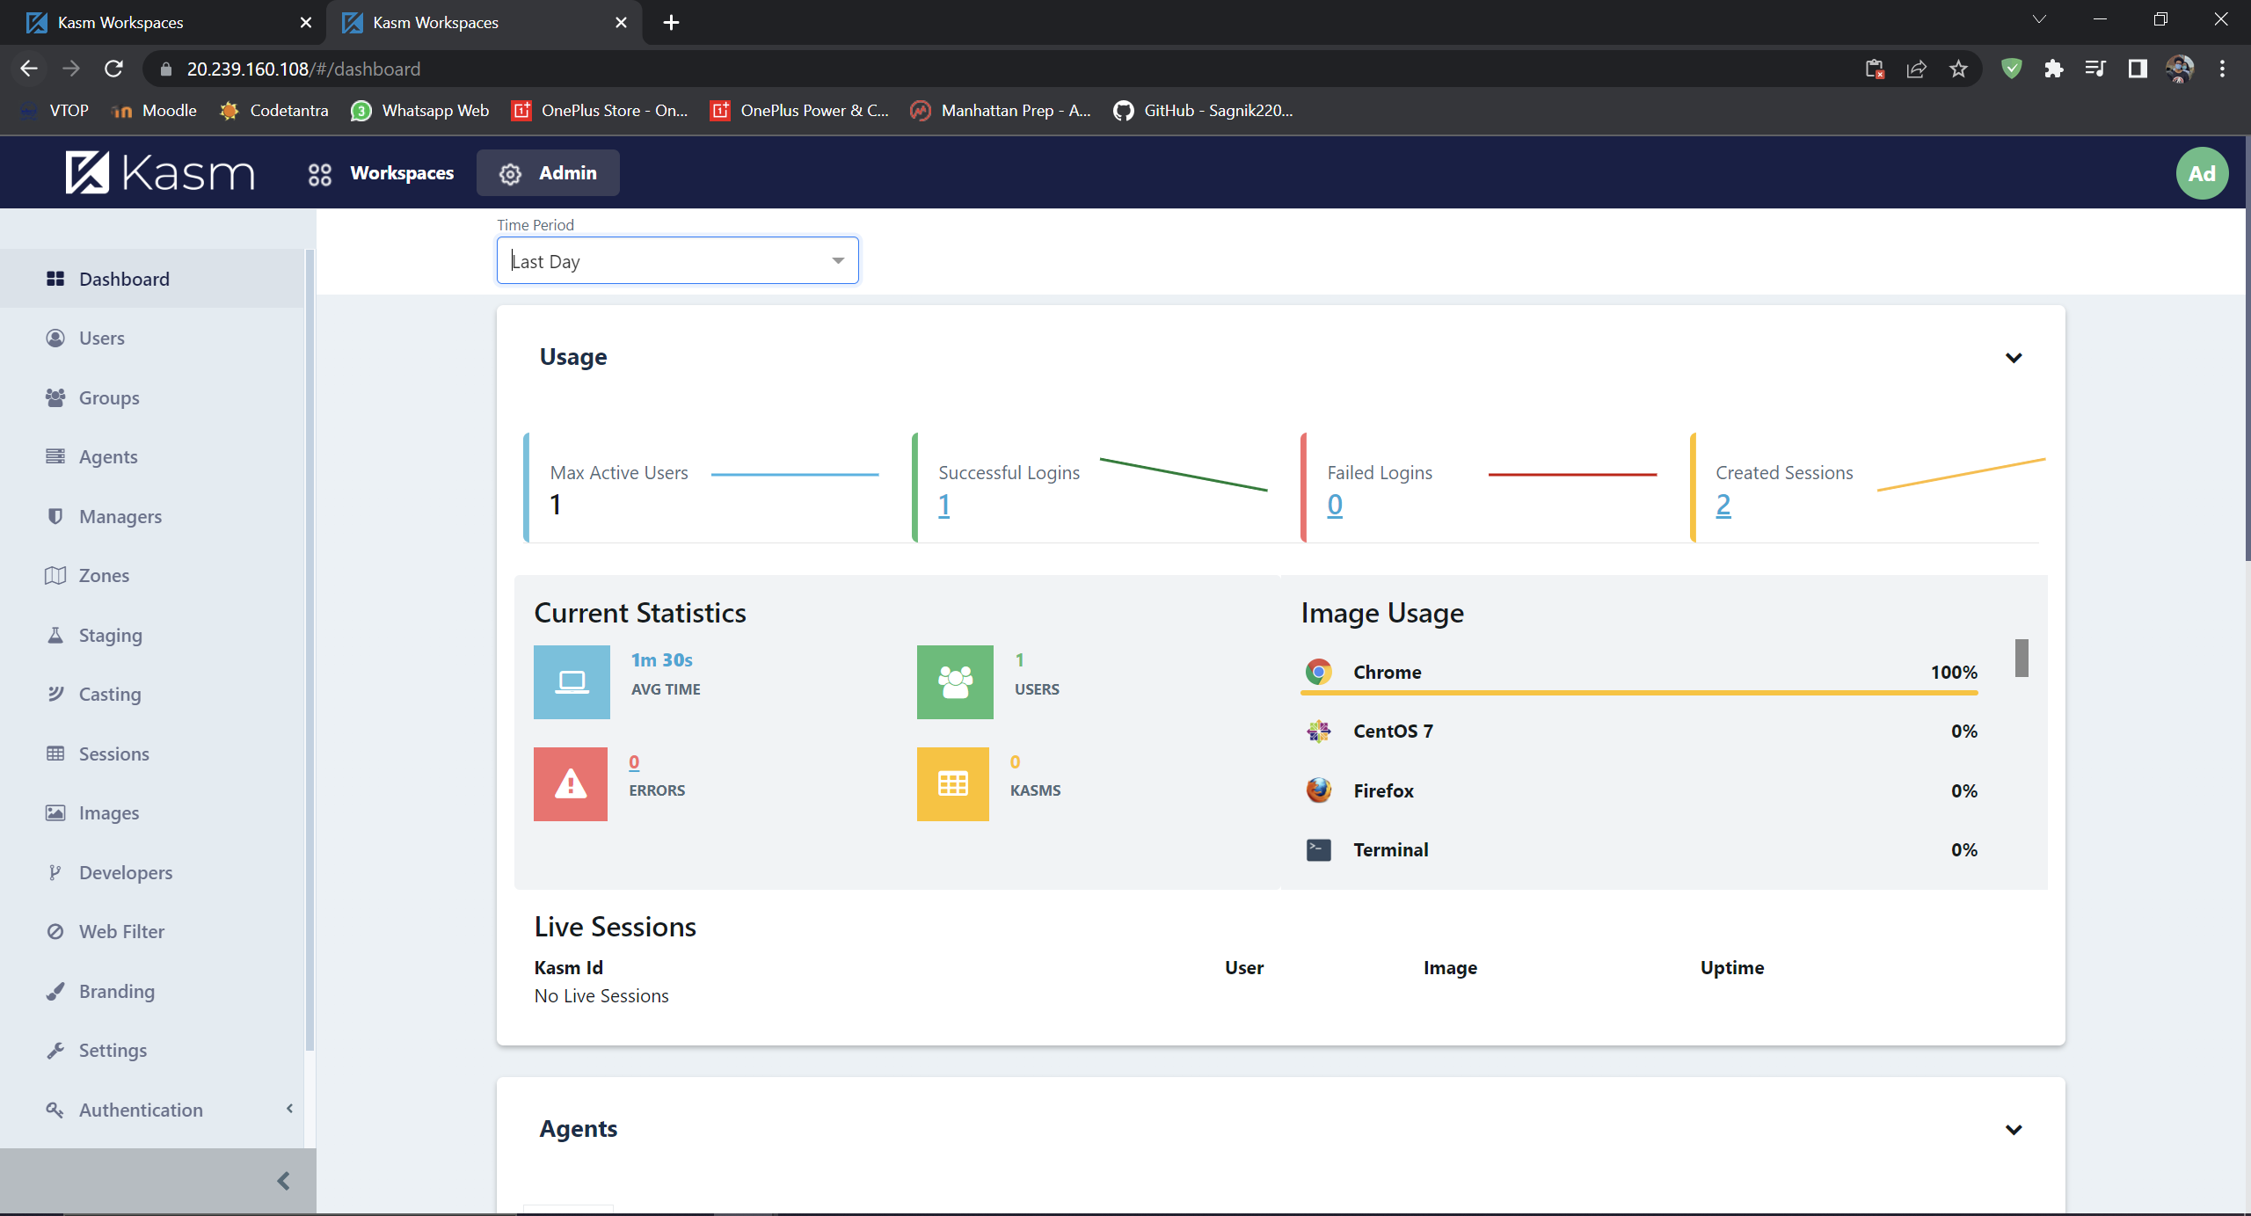

*Figure 7- Kasm Workspace*

**Setting up an option of “Open in Kasm” option in the right click menu of links in Chrome**

* Go to Chrome Extensions Store and install “Kasm: Open in Isolation”.
* Go to the extension options and add url of our kasm server and select if you want to open new window or new tab.
* Inside Kasm Workspace, go the Profile.
* Then Select the Default Workspace Image as per your choice. We choose Chrome.
* Now try it out by right clicking it on any link and selecting “Open in Kasm” option.

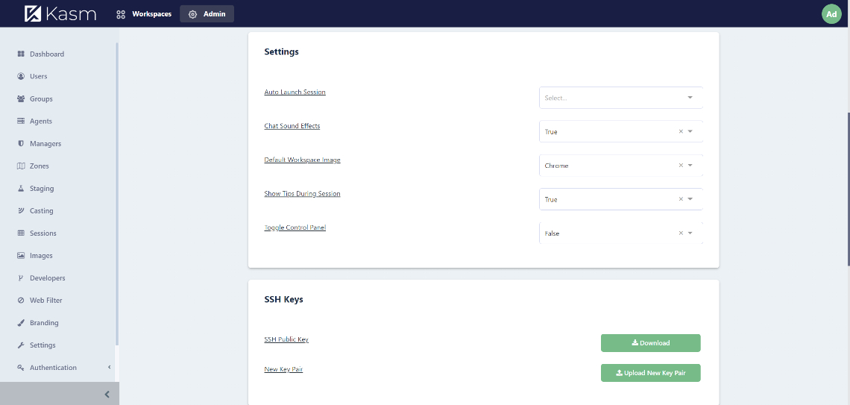  
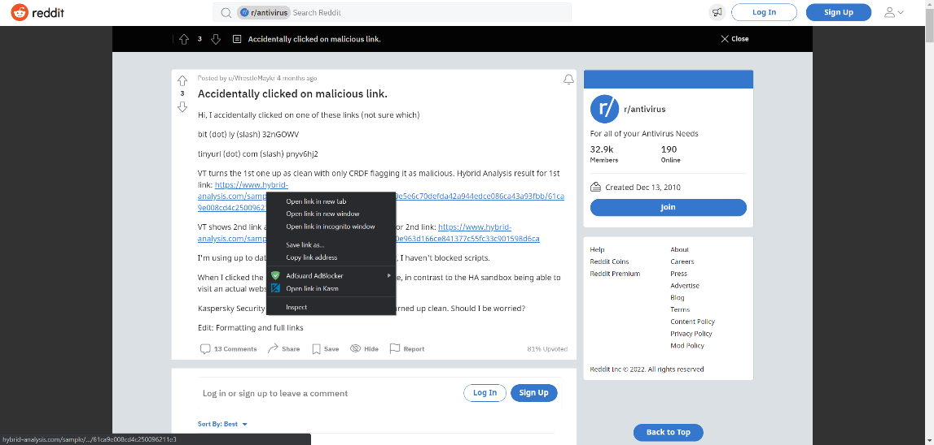

*Figure 8- Opening malicious link in Kasm*

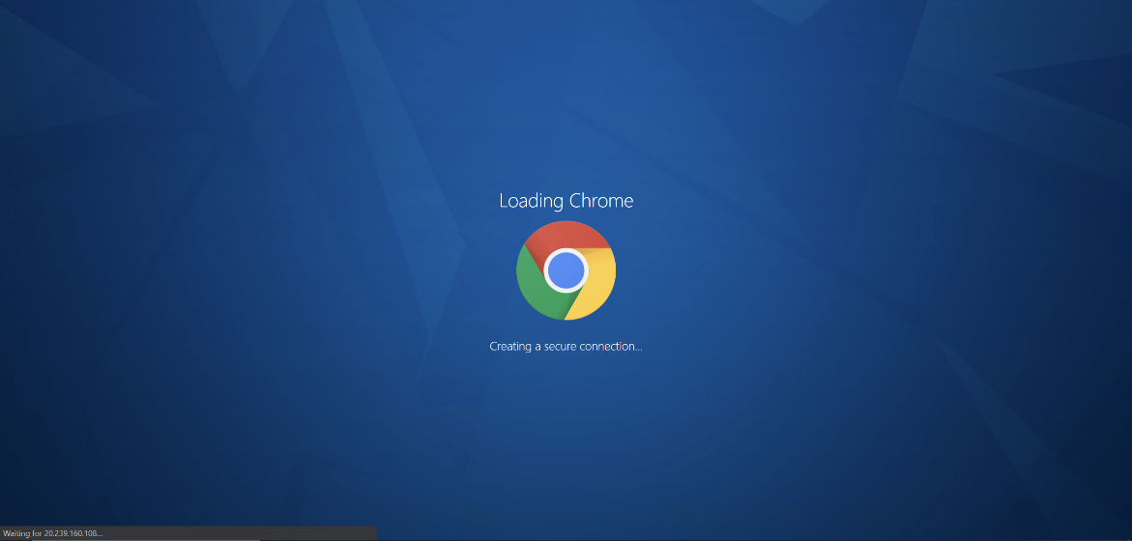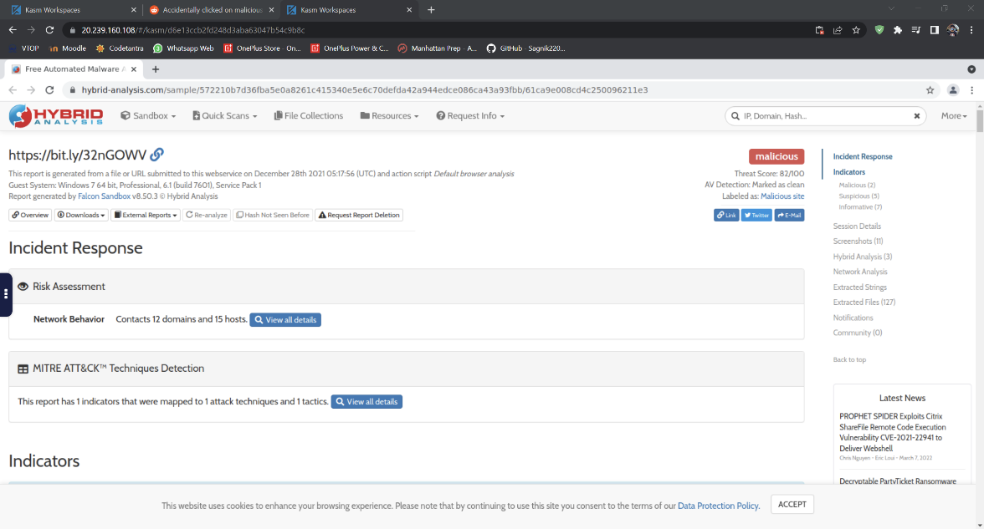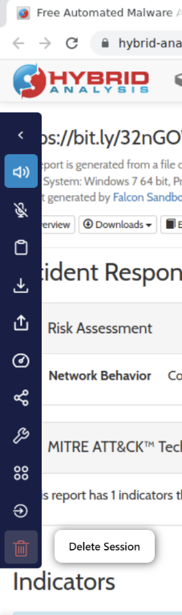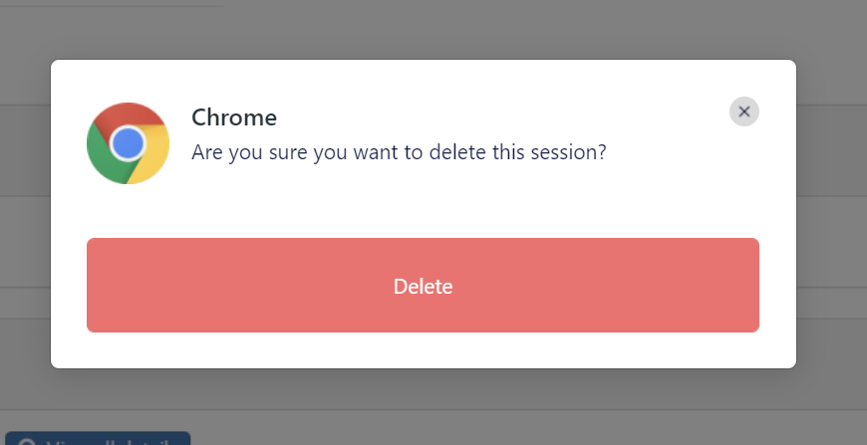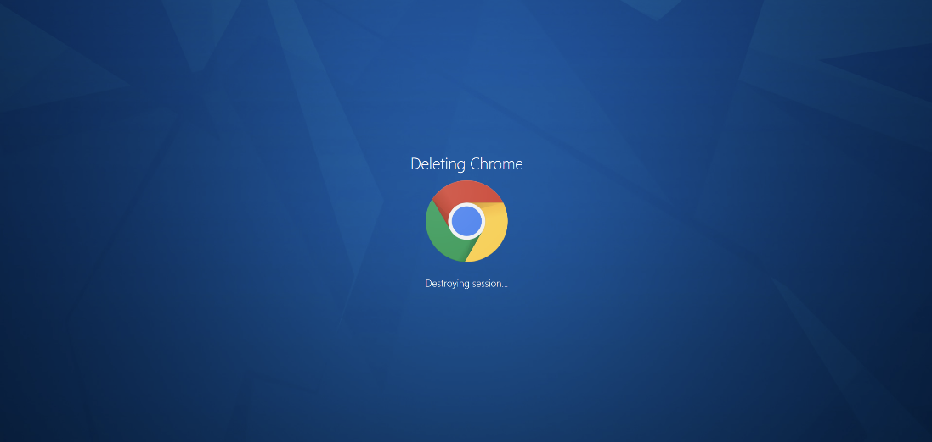

*Figure 9- Link opened in Chrome in Server and was streamed in the native browser tab. Deletion of the entire session is also shown*

**Setting up Kali Linux as a Workspace**

* Go to Images in Kasm workspace
* Find Kali
* Click on Edit and click on the Enable checkbox
* This is going to log us in as a regular user without root access. But of course, we want root access.
* For that, we set ‘ {“user”:”root”} ’ inside “Docker Run Config Override (JSON)”.
* Click on Submit and let it install.

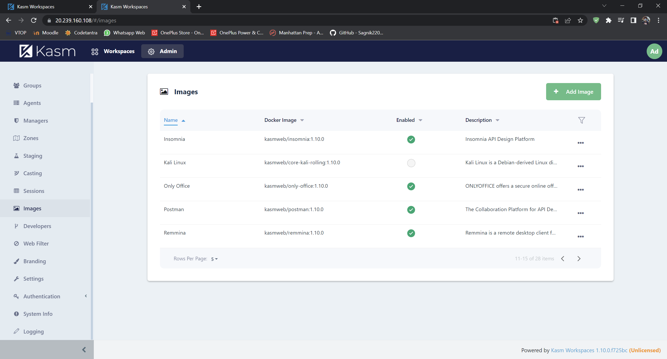

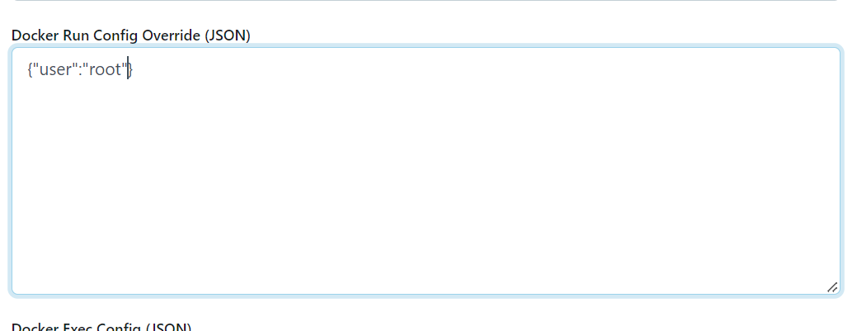

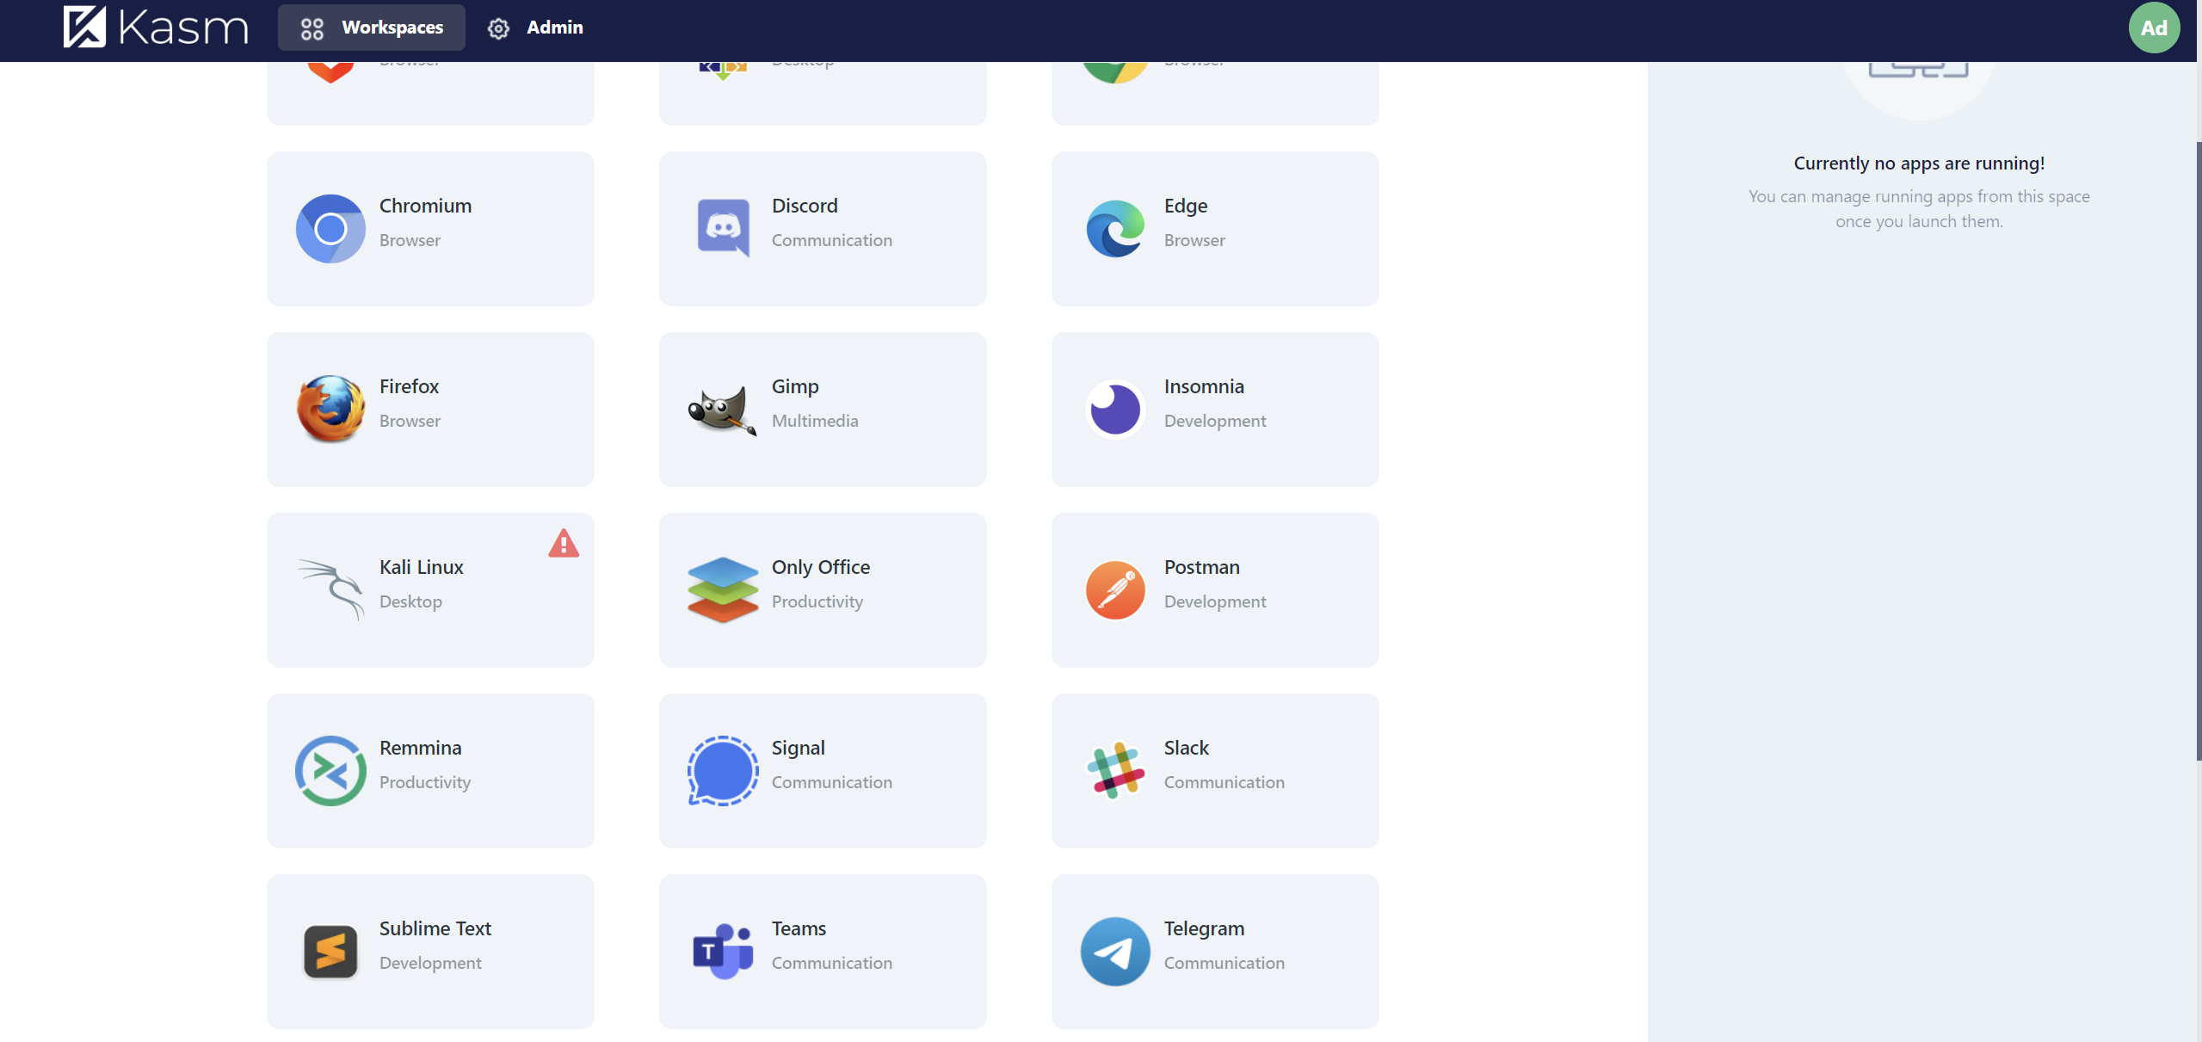

*Figure 10- Setting up Kali Linux as a workspace*

# RESULTS AND CONCLUSION

This amazing ultimate setup of a hacking lab carries a lot of features and will help a lot of ethical hackers out there with their daily research on malwares and viruses and security. It can also be installed in businesses and companies to increase their security. It can also be used at home and can be beneficial in many ways as this workspace allows for multiple users. The admin can turn on Web Filtering to filter out the sites he/she wants to be blocked for everybody or specific users. For example, blocking of adult sites for children or filtering of social media sites in office. This is definitely something that needs to be used on a daily basis but the drawback is having a good internet connection as well as a mid-tier system to operate on.

# REFERENCES

1. Alin Calinciuc, Cristian Constantin Spoiala, Corneliu Octavian Turcu, Constantin Filote, “OpenStack and Docker: building a high-performance IaaS platform for interactive social media applications”, May 19-21, 2016.
2. Bukhary Ikhwan Ismail, Ehsan Mostajeran Goortani, Mohd Bazli Ab Karim, Wong Ming Tat, Sharipah Setapa, Jing, Yuan Luke, Ong Hong Hoe, “Evaluation of Docker as Edge Computing Platform”., 2015 Advanced Computing Lab
3. Fawaz Paraiso, St´ephanie Challita, Yahya Al-Dhuraibi, Philippe Merle, “Model-DrivenManagement of Docker Containers”., University of Lille & Inria Lille - Nord Europe 2016.
4. Pankaj Mendki, “Docker container-based analytics a IoT edge”., Senior Principal Engineer, Member of R&D 2018.
5. Dong-Ki Kang, Gyu-Beom Choi, Seong-Hwan Kim, II-Sun Hwang and Chan-Hyun Youn, “Workload-aware Resource Management for Energy Efficient Heterogeneous Docker Containers”., School of Electrical Engineering.
6. Containers vs. VMs: What's the difference? <http://searchservervirtualization.techtarget.com/answer/Containers-vs-VMs-Whats-the-difference>.
7. Understanding the architecture <https://docs.docker.com/engine/understanding-docker/>.
8. M. Raho, A. Spyridakis, M. Paolino, D. Raho, “KVM, Xen and Docker: a performance analysis for ARM based NFV and Cloud computing,” IEEE 3rd Workshop on Advances in Information, Electronic and Electrical Engineering (AIEEE), pp. 1–8, November 2015.
9. R. R. Yadav, E. T. G. Sousa, and G. R. A. Callou, Docker Containers Versus Virtual Machine-Based Virtualization: Proceedings of IEMIS 2018.
10. Deploy Docker Open Source, or Enterprise for High Performing Systems, <https://www.flux7.com/tech/container-technology/docker/>
11. Chao Zheng and Douglas, Integrating Containers into Workflows: A Case Study Using Makeflow, Work Queue, and Docker.
12. Control Desk existing solution: A containerization case study with Docker <https://developer.ibm.com/technologies/containers/articles/containerizationdocker-case-study>.

**APPENDIX**<Sample code, snapshot etc.>



